Water Level Monitoring Using HC-SR04 Sensor and Arduino IoT Cloud

Rayan alshubli
221423496

Ahmed mansour
221433714
Suervision : Dr.abdullah albuali

Abstract
The objective of this project is to design and implement a real-time water level monitoring system using an HC-SR04 ultrasonic sensor integrated with the Arduino IoT Cloud. The system measures the water level and displays the data on an online dashboard, providing real-time updates to users through a Gauge widget. This innovative approach is particularly beneficial for monitoring water levels in flood-prone areas, where early detection and continuous monitoring are crucial for ensuring safety. The Arduino IoT Cloud platform enables easy setup and remote access, allowing users to monitor the water levels from anywhere. By linking the sensor data to a visual representation on the cloud dashboard, the system offers a user-friendly solution for tracking water levels efficiently. The project demonstrates the feasibility of using affordable hardware and cloud technology to address environmental monitoring challenges.
Keywords HC-SR04 Sensor, Arduino IoT Cloud, Arduino Board, Distance Sensor, Water Level Sensor, Gauge Widget, IoT Dashboard.
Formatting: Real-Time Data, Cloud Integration, Dashboard Setup, Data Visualization.

Introduction (Heading 1)
Water level monitoring is crucial for managing water resources, preventing flooding, and ensuring environmental safety, especially in flood-prone areas. Traditional water level measurement systems can be cumbersome, expensive, and often lack real-time monitoring capabilities. This project proposes a solution using an HC-SR04 ultrasonic sensor integrated with the Arduino IoT Cloud to create an affordable and efficient water level monitoring system.
The system uses the HC-SR04 ultrasonic sensor to measure the distance to the water surface, providing an accurate real-time reading of the water level. The sensor’s data is transmitted to the Arduino IoT Cloud, where it is displayed on a dashboard using a Gauge widget. This visual representation allows users to easily track the water level and receive immediate updates, providing an essential tool for flood monitoring and prevention.
By leveraging cloud technology and Internet of Things (IoT) principles, the system offers a scalable solution that can be remotely accessed and monitored from anywhere. The project's objective is to develop a low-cost, easy-to-implement solution that enhances real-time water level monitoring, making it accessible to both communities and industries with limited resources.
This report outlines the methodology, components used, system setup, and results of the water level monitoring project, demonstrating its feasibility and potential applications in environmental monitoring..

Ease of Use
One of the primary goals of this water level monitoring system is to ensure ease of use for all users, from setup to daily monitoring. The system is designed with simplicity and accessibility in mind, leveraging Arduino IoT Cloud for easy cloud-based integration and real-time monitoring.
1. User-Friendly Interface
The Arduino IoT Cloud platform provides an intuitive interface that simplifies the process of connecting and managing devices. Setting up the water level monitoring system involves a few straightforward steps, including creating a "Thing" in the cloud, linking the HC-SR04 sensor to the system, and configuring the dashboard. The Gauge widget on the dashboard automatically reflects the sensor’s readings, offering users a clear visual representation of water levels.
2. Real-Time Monitoring
Once the system is set up, users can monitor water levels in real-time via the dashboard, which can be accessed from any device with an internet connection. The data is updated dynamically, making it easy to observe fluctuations in water levels, and receive alerts if the levels reach critical thresholds. This real-time capability eliminates the need for manual checks, making the system highly efficient and reliable.
3. Remote Access
The cloud-based setup allows users to access the system remotely, which is particularly beneficial for applications in remote or hard-to-reach locations. Whether monitoring a water tank, river, or flood-prone area, users can receive up-to-date information from anywhere without having to be physically present at the monitoring site.
4. Minimal Maintenance
The system requires minimal maintenance once it’s set up. The HC-SR04 sensor is simple to install, and its calibration and operation are automatic, ensuring the system remains reliable over time. Regular checks for debris or environmental factors affecting the sensor's range are all that’s needed to keep the system operational.

METHODOLOGY
The system is built using an HC-SR04 ultrasonic sensor and the Arduino IoT Cloud platform. The methodology can be broken down into the following steps:

Wiring diagram

Arduino IoT Cloud Configuration
A “Thing” is created in the Arduino IoT Cloud to manage sensor data.
A distance variable is defined to store the water level readings from the sensor.

Data Handling
The sensor continuously sends distance data to the cloud, where it is processed and displayed to the user.
Real-time updates are provided on the dashboard, and users can view the water level remotely.

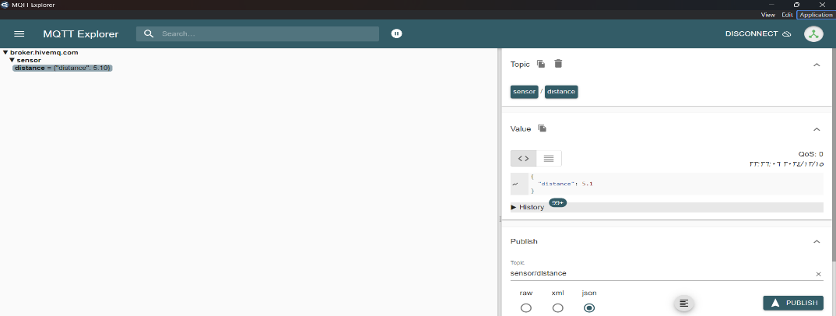

Testing and Verification
During the testing phase, the system was evaluated for its performance in updating and displaying data in real-time. The distance variable was successfully updated on the Arduino IoT Cloud and reflected immediately on the Dashboard. As the water level changed, the Gauge widget dynamically displayed the updated values, offering a clear visual representation of the water level fluctuations. This verification process confirmed that the data was being transmitted from the sensor to the cloud accurately, and that the readings were correctly displayed on the Dashboard, as intended.
Additionally, the real-time monitoring capability of the system was thoroughly tested. The Gauge widget on the Dashboard updated continuously, reflecting any changes in the water level in real-time. The system proved to be highly reliable in displaying water levels accurately, ensuring that users could monitor the data with minimal delay. These results confirmed that the system was functioning as expected, successfully providing dynamic, real-time updates of the water level, which is crucial for effective monitoring.

Benefits and Challenges
The water level monitoring system offers several significant benefits. Real-time monitoring and visualization is one of the key advantages. The data from the sensor is displayed instantly on the Arduino IoT Cloud Dashboard using a Gauge widget, providing a clear and interactive visual representation of the water level. This real-time display makes it easy for users to monitor the water level at any given time, ensuring prompt responses in case of fluctuations or emergencies.
Another major benefit is data storage and analysis. While the primary focus of the system is on real-time monitoring, the Arduino IoT Cloud also enables the storage of historical data, allowing for future reference and analysis. This feature is essential for tracking trends over time, providing valuable insights into water level patterns and helping users anticipate potential issues such as floods or droughts.
Additionally, the system offers data interactivity through the Gauge widget. The Dashboard not only displays the water level but also allows for interactive monitoring, which means users can take immediate action based on the information displayed. This responsiveness is crucial in critical situations where swift decisions are needed to prevent or manage water-related hazards.
While these benefits highlight the system’s effectiveness, there may still be challenges to address, such as sensor calibration in extreme weather conditions or ensuring consistent cloud connectivity. However, the advantages in real-time monitoring, data accessibility, and interactivity make this system a powerful tool for water level management.

RESULTS AND DISCUSSION
The system successfully measures and displays water levels in real-time using the HC-SR04 sensor and Arduino IoT Cloud. The Gauge widget provides an accurate visual representation of the water level, making it easy for users to monitor the data continuously.
The Arduino IoT Cloud platform allows for seamless remote access and monitoring of the system, making it ideal for applications in flood-prone areas or locations where constant human presence is impractical.
Through testing, the system has demonstrated its reliability, providing accurate data with minimal latency. The ease of setup and the low-cost nature of the hardware make it a highly viable option for widespread implementation.

CONCLUSION
This project successfully demonstrated the feasibility of using an HC-SR04 ultrasonic sensor integrated with Arduino IoT Cloud to create an efficient and affordable water level monitoring system. The real-time data updates, remote monitoring, and user-friendly dashboard make this system suitable for applications in flood monitoring, water resource management, and other environmental monitoring scenarios. The system’s low cost, ease of use, and minimal maintenance requirements make it an accessible solution for both individuals and organizations. Future work could explore integrating additional sensors and automation to further enhance the system’s capabilities.

Future Improvements
- Improving Data Accuracy: Additional techniques, such as data filtering or moving averages, can be implemented to improve measurement accuracy and reduce the impact of environmental factors on the sensor readings.
- Adding Alerts: Alerts can be integrated via Arduino IoT Cloud or MQTT when the water level exceeds a certain threshold. This would trigger timely actions such as notifying concerned authorities or triggering alarms.

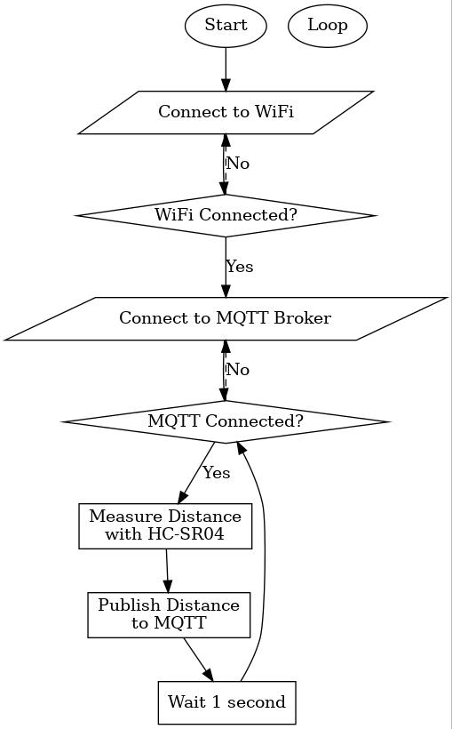

The flowchart illustrates the sequence of steps in the provided code, which involves connecting an ESP32 to a WiFi network, publishing distance data from an ultrasonic sensor to an MQTT broker, and ensuring continuous operation.

Flowchart Steps:

Start:

The program begins execution.

Connect to WiFi:

The ESP32 attempts to connect to the specified WiFi network using the provided credentials.

Check WiFi Connection:

If the connection is successful, proceed to the next step.

If not, retry connecting to WiFi.

Connect to MQTT Broker:

Once WiFi is connected, the ESP32 attempts to establish a connection with the MQTT broker using the given server and port.

Check MQTT Connection:

If the connection is successful, proceed to measure distance.

If not, retry connecting to the MQTT broker.

Measure Distance:

The ultrasonic sensor (HC-SR04) calculates the distance by triggering a pulse and measuring the response time.

Publish Distance to MQTT:

The calculated distance is formatted as a JSON message and published to the specified MQTT topic.

Wait 1 Second:

The program pauses for 1 second before repeating the loop.

Loop Back:

The process repeats from checking the MQTT connection, ensuring the program maintains connectivity and continues publishing data.

References

- A. M. G. I. Rodrigues and F. J. A. Santos, "Water Level Monitoring using ESP8266 and Arduino IoT Cloud," Electronic Clinic, 2021. [Online]. Available: https://www.electroniclinic.com. [Accessed: Dec. 11, 2024].
- P. G. Sharma, "IoT based Contactless Water Level Monitoring with ESP32 and HC-SR04," Microcontrollers Lab, 2021. [Online]. Available: https://www.microcontrollerslab.com. [Accessed: Dec. 11, 2024].
- Martinius96, "Water Level Monitor using Arduino/ESP32/IoT," GitHub Repository, 2021. [Online]. Available: https://github.com/martinius96/hladinomer-studna-scripty. [Accessed: Dec. 11, 2024].
- R. Chatterjee, "Automated Water Level Monitoring and Control System," GitHub Repository, 2021. [Online]. Available: https://github.com/chatterjee-rohan/Automated-Water-Level-Monitoring. [Accessed: Dec. 11, 2024].
- M. Martinius, "Water Level Monitor - Arduino / ESP8266 / ESP32 / Sigfox," Arduino Project Hub, 2022. [Online]. Available: https://projecthub.arduino.cc/martinius96/water-level-monitor-arduino-esp8266-esp32-sigfox-21ede7. [Accessed: Dec. 11, 2024].
- Y. Yamin, "Water Level Monitoring Using NodeMCU ESP8266 and HC-SR04P Ultrasonic Sensor," GitHub Repository, 2021. [Online]. Available: https://github.com/yamin8000/WaterLevel. [Accessed: Dec. 11, 2024].
- M. Martinius, "Water Level Monitor IoT Dashboard for Arduino, ESP8266, ESP32," GitHub Repository, 2021. [Online]. Available: https://martinius96.github.io. [Accessed: Dec. 11, 2024].

Appendixes

/*
Sketch generated by the Arduino IoT Cloud Thing "Untitled"
https://create.arduino.cc/cloud/things/da573d01-3d3d-4288-8ba6-7c48dd59d47a
Arduino IoT Cloud Variables description
The following variables are automatically generated and updated when changes are made to the Thing
float distance;
Variables which are marked as READ/WRITE in the Cloud Thing will also have functions
which are called when their values are changed from the Dashboard.

#include <WiFi.h>
#include <PubSubClient.h>

// WiFi credentials
const char* ssid = "Huawei-87EA"; // اسم شبكة WiFi
const char* password = "66072157"; // كلمة مرور شبكة WiFi

// MQTT Broker settings
const char* mqttServer = "broker.hivemq.com"; // خادم HiveMQ
const int mqttPort = 1883; // المنفذ الافتراضي
const char* mqttTopic = "sensor/distance"; // اسم الموضوع لإرسال البيانات

WiFiClient espClient;
PubSubClient client(espClient);

const int trigPin = 23; // Pin connected to Trigger
const int echoPin = 22; // Pin connected to Echo
float distance;

void setup() {
Serial.begin(9600);

// Connect to WiFi
WiFi.begin(ssid, password);
while (WiFi.status() != WL_CONNECTED) {
delay(500);
Serial.print(".");
}
Serial.println("\nConnected to WiFi");

// Connect to MQTT broker
client.setServer(mqttServer, mqttPort);
connectToMQTT();

// Set up HC-SR04 pins
pinMode(trigPin, OUTPUT);
pinMode(echoPin, INPUT);
}

void loop() {
if (!client.connected()) {
connectToMQTT();
}
client.loop();

// Calculate distance
digitalWrite(trigPin, LOW);
delayMicroseconds(2);
digitalWrite(trigPin, HIGH);
delayMicroseconds(10);
digitalWrite(trigPin, LOW);

long duration = pulseIn(echoPin, HIGH);
distance = duration * 0.034 / 2;

// Publish data to MQTT topic
char message[50];
sprintf(message, "{\"distance\": %.2f}", distance);
client.publish(mqttTopic, message);

Serial.print("Published distance: ");
Serial.println(message);

delay(1000);
}

void connectToMQTT() {
while (!client.connected()) {
Serial.print("Connecting to MQTT...");
if (client.connect("ESP32Client")) {
Serial.println("Connected to MQTT broker");
} else {
Serial.print("Failed, rc=");
Serial.println(client.state());
delay(2000);
}
}
}

